**Please rate the following statements about your interaction with the Student Dietitian.** Please tick one box for each statement.

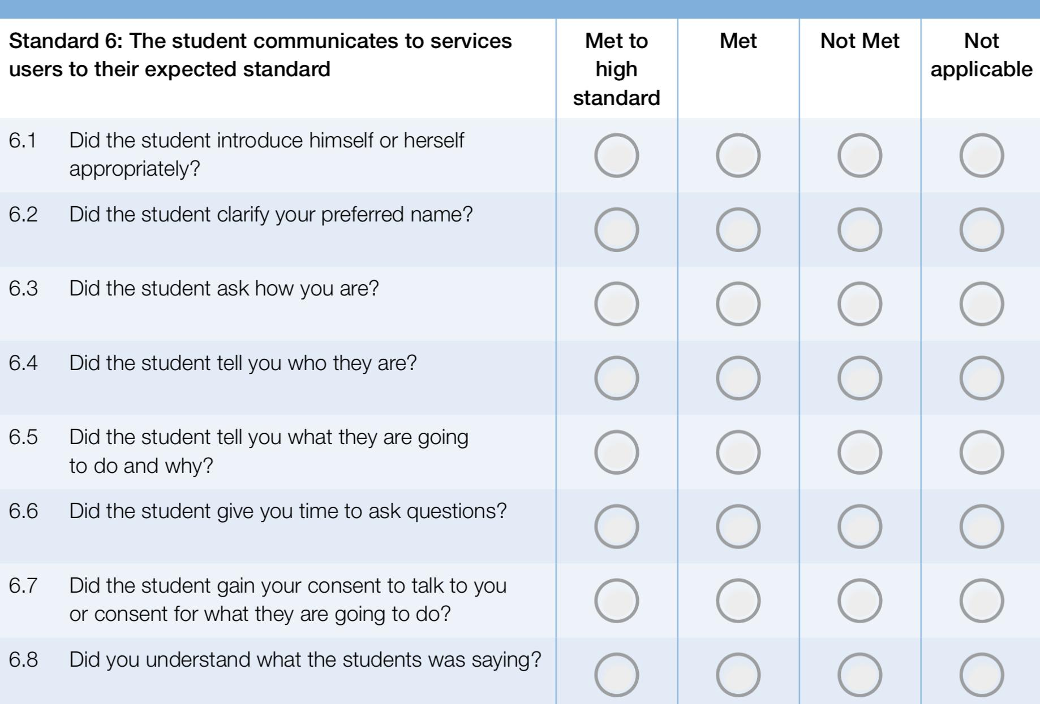

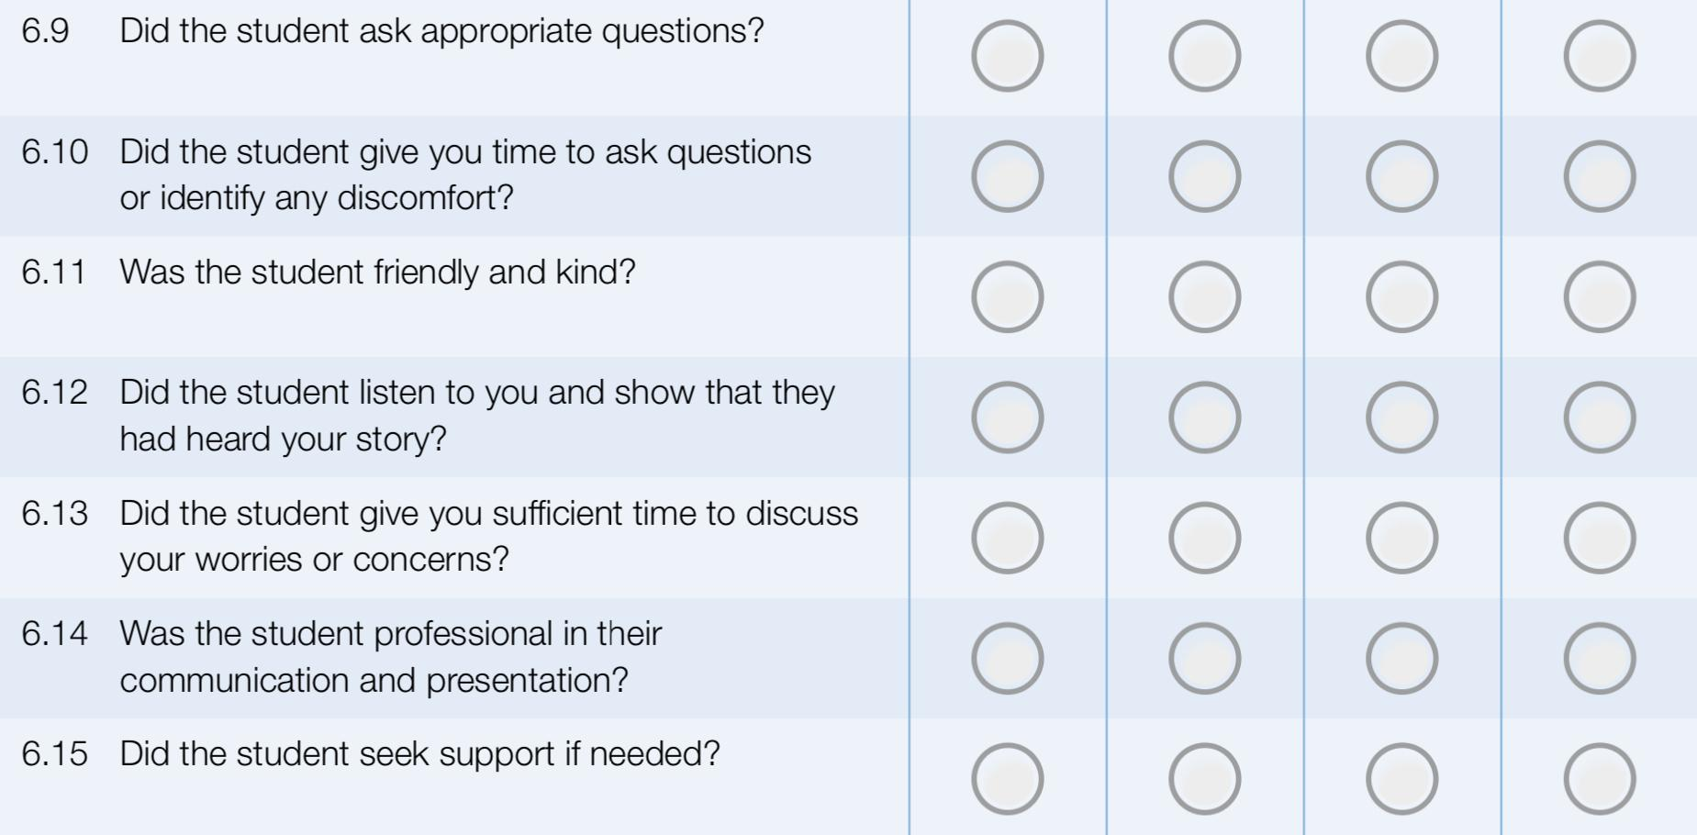

**THANK YOU FOR TAKING THE TIME TO PROVIDE YOUR FEEDBACK**